1. Create one IAM user and assign EC2 and S3 full access roles.

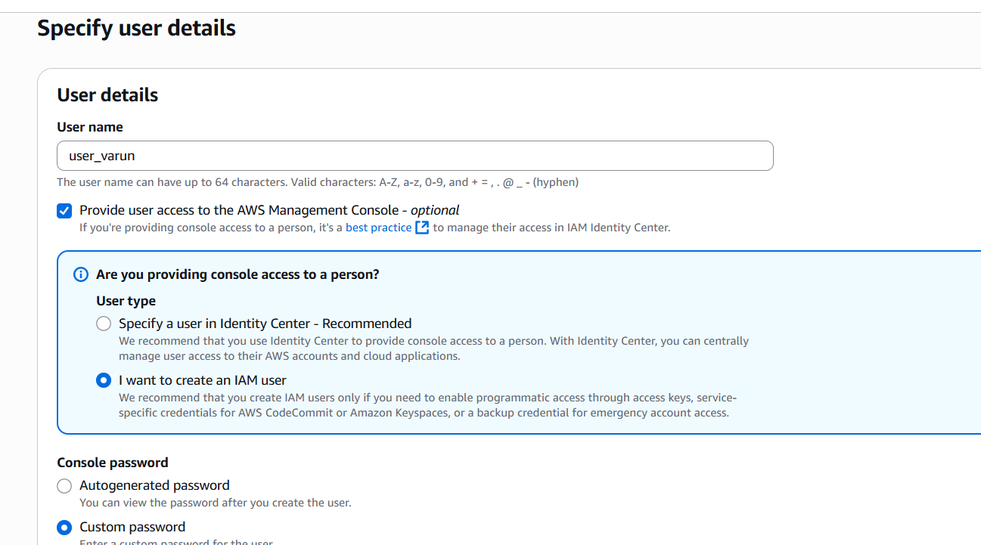

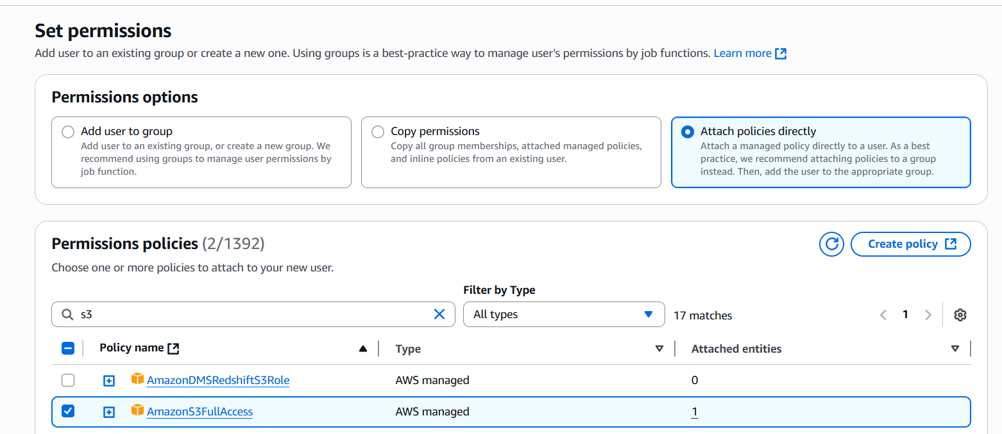

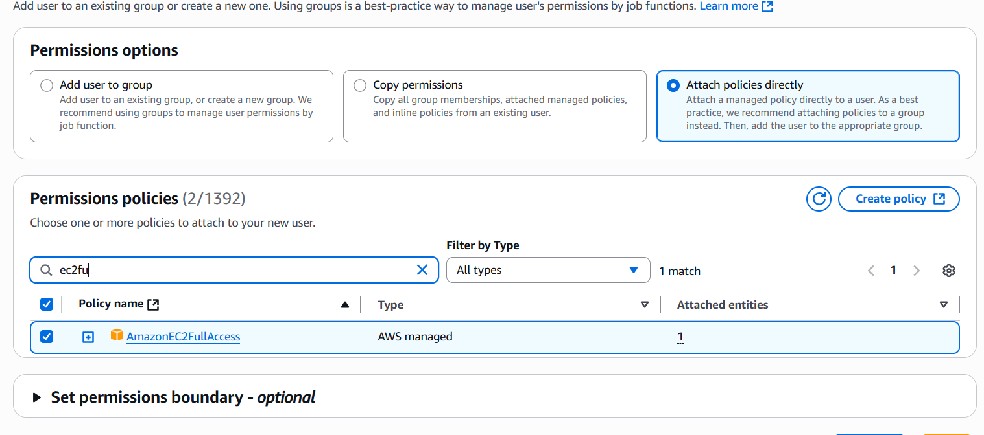

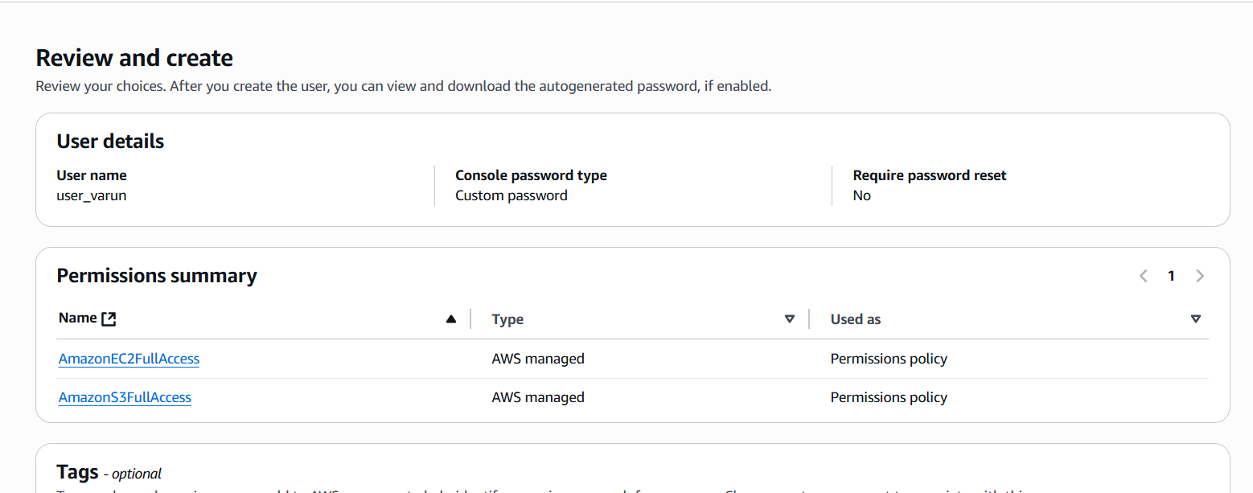

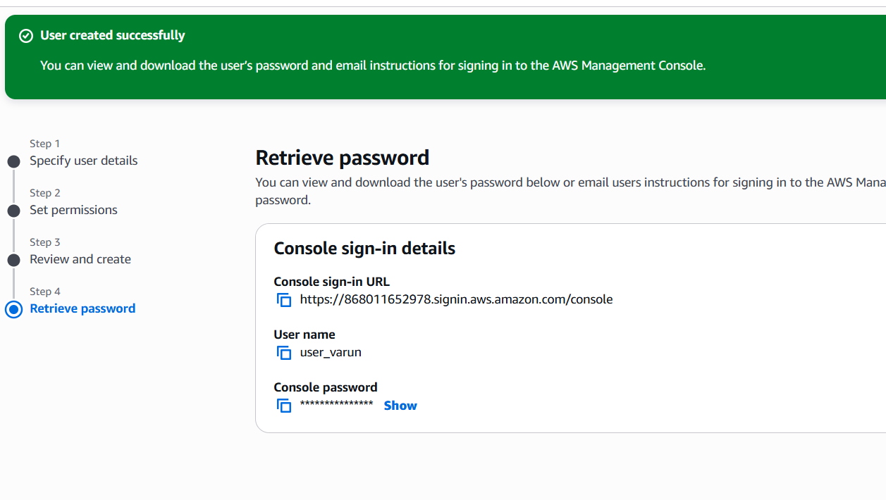

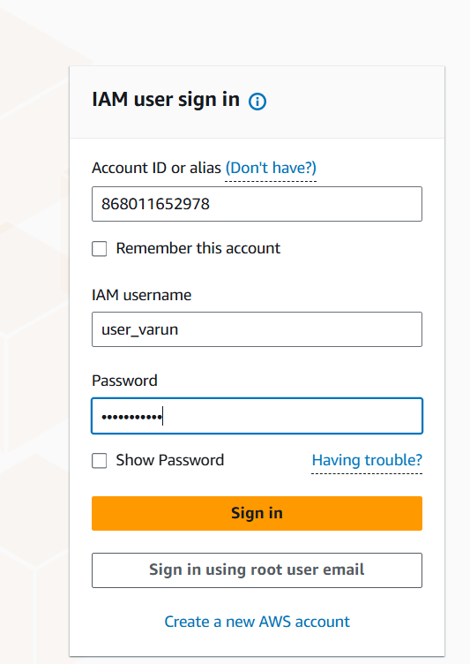

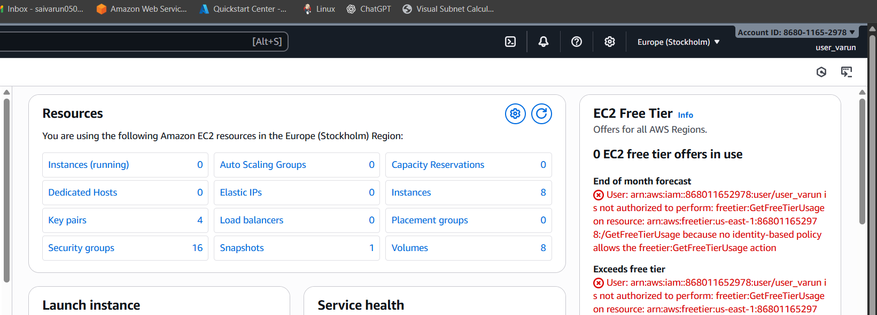

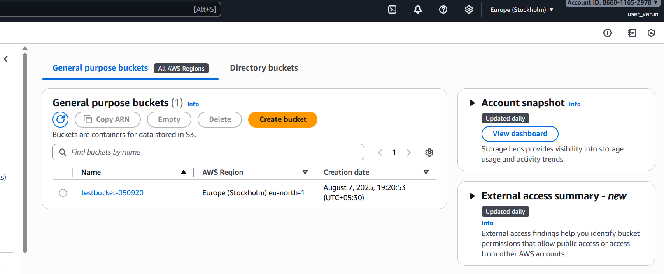

* Login to root user of aws console.
* Go to IAM services and click Users and create a user as above images.
* It will create an IAM user within the root aws account.
* Attach the ec2fullaccess, s3fullaccess policy to them.
* After creating, login to AWS console by IAM user, user id and password.
* Then check the ec2 and s3 are having full access to the created IAM user.

1. Create one group in IAM and assign read access for EC2.

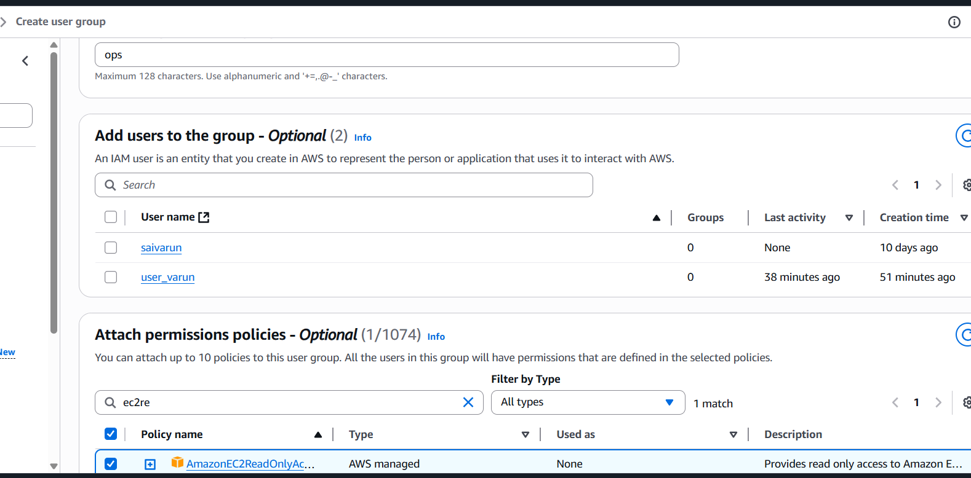

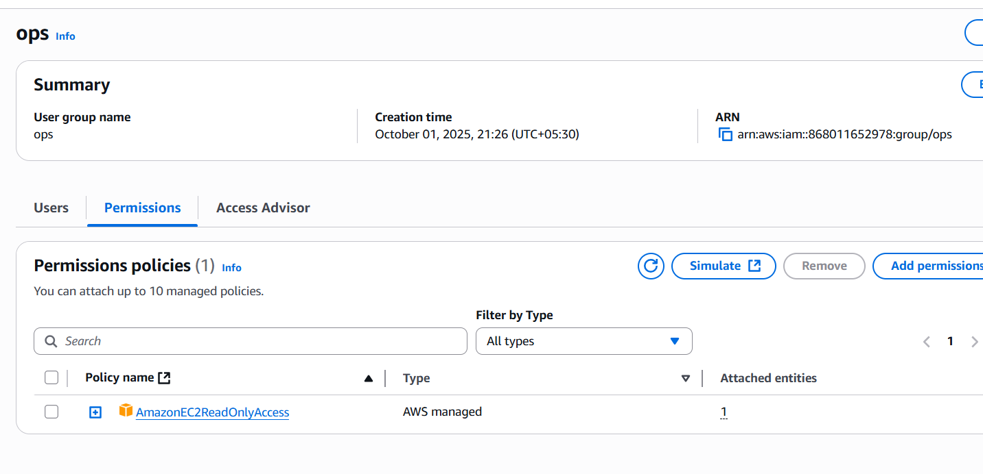

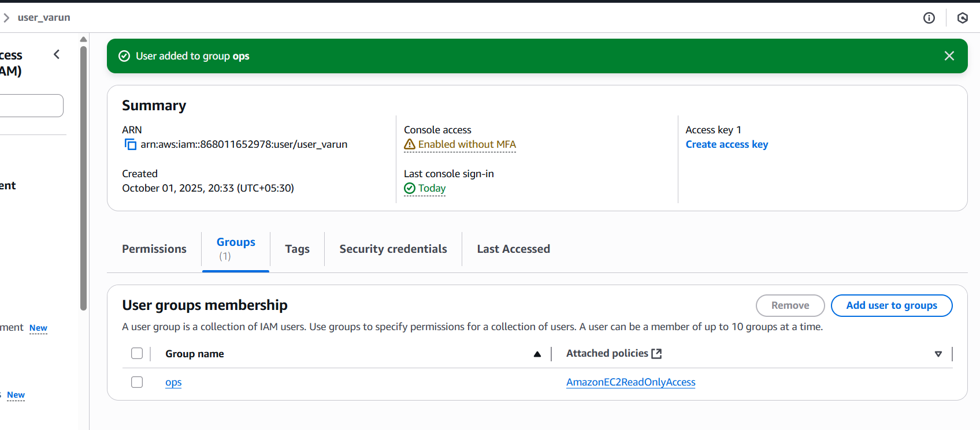

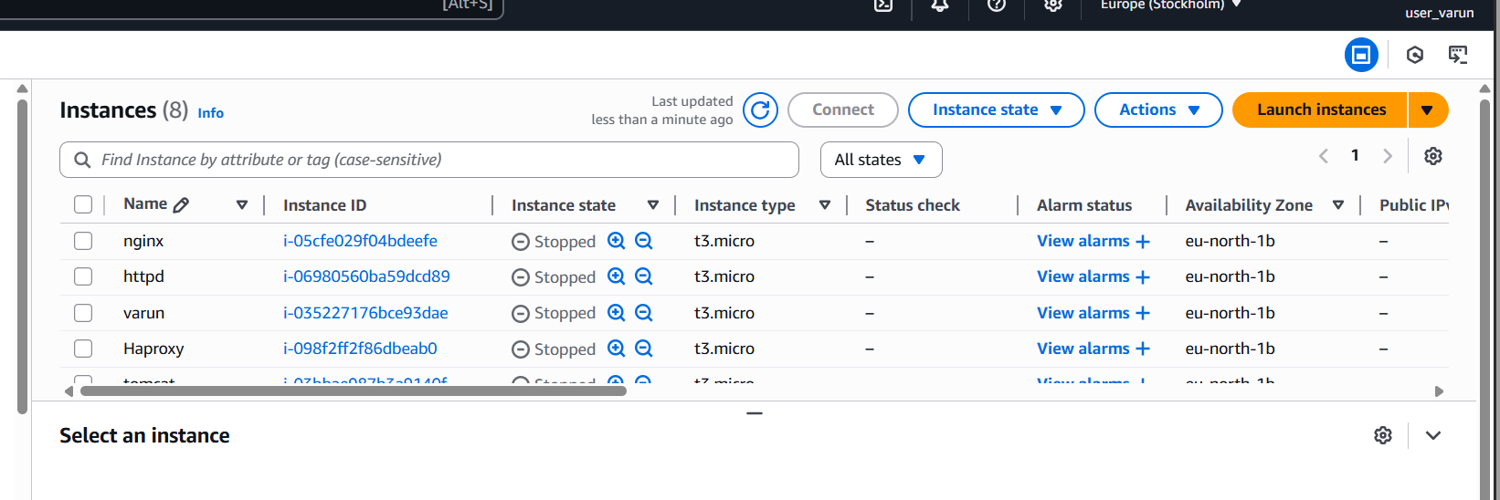

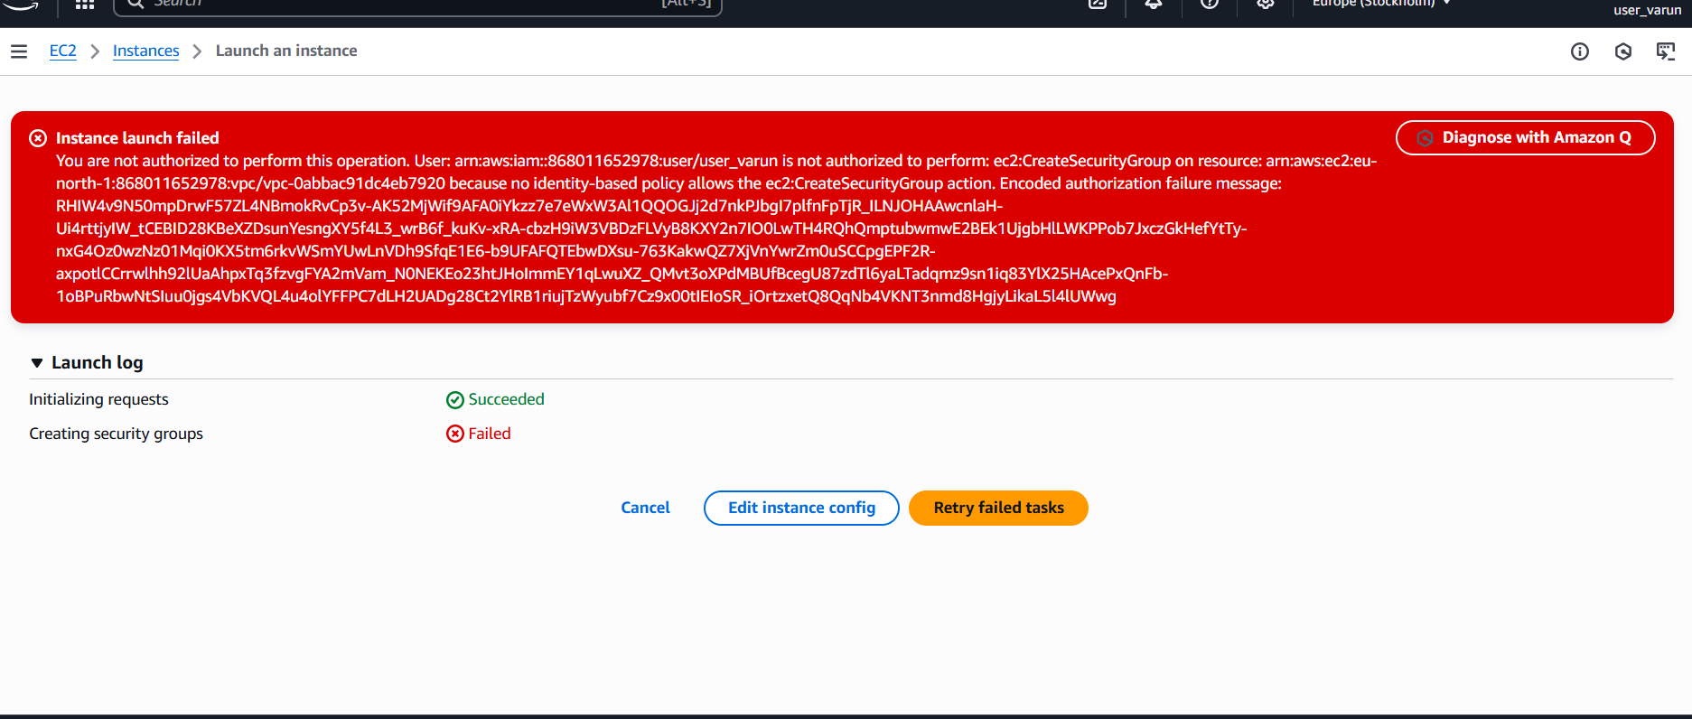

* Navigate to IAM
* In the search bar, type IAM and select it.
* In the left sidebar, click User groups.
* Create a New Group
* Click Create group.
* Enter a Group name (e.g., EC2ReadOnlyGroup).
* Attach Permissions
* Under Attach permissions policies, search for: AmazonEC2ReadOnlyAccess
* Add the policy and check.

1. Create a new user named "Devops" and add to the group created in task 2.

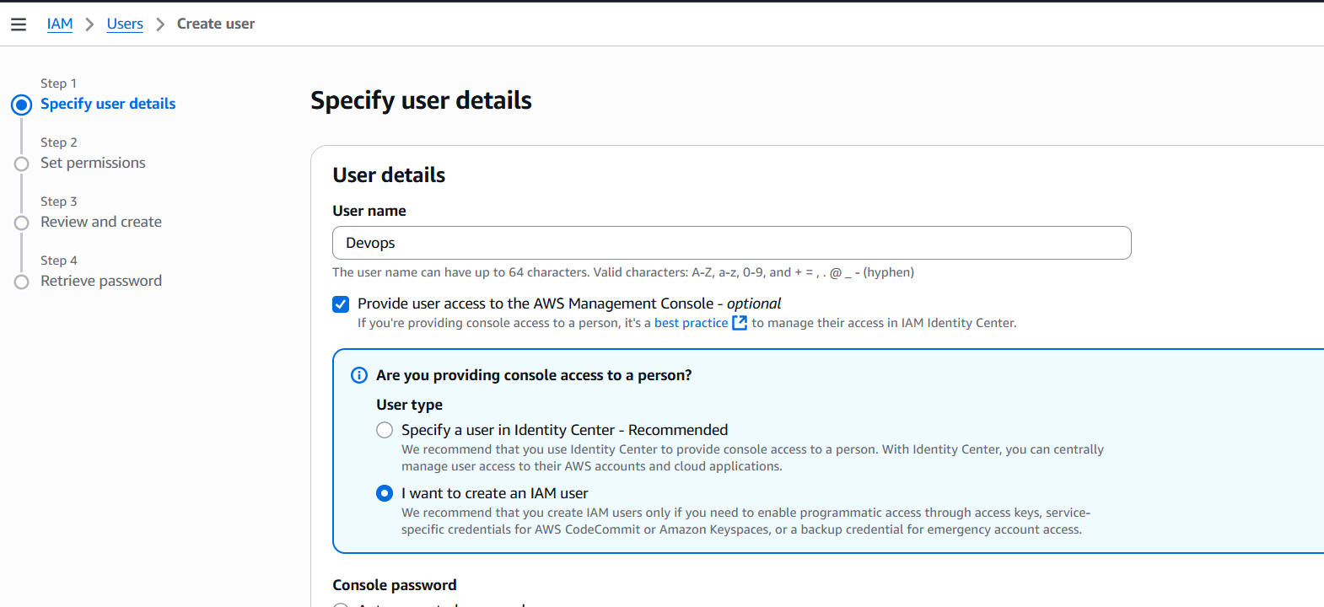

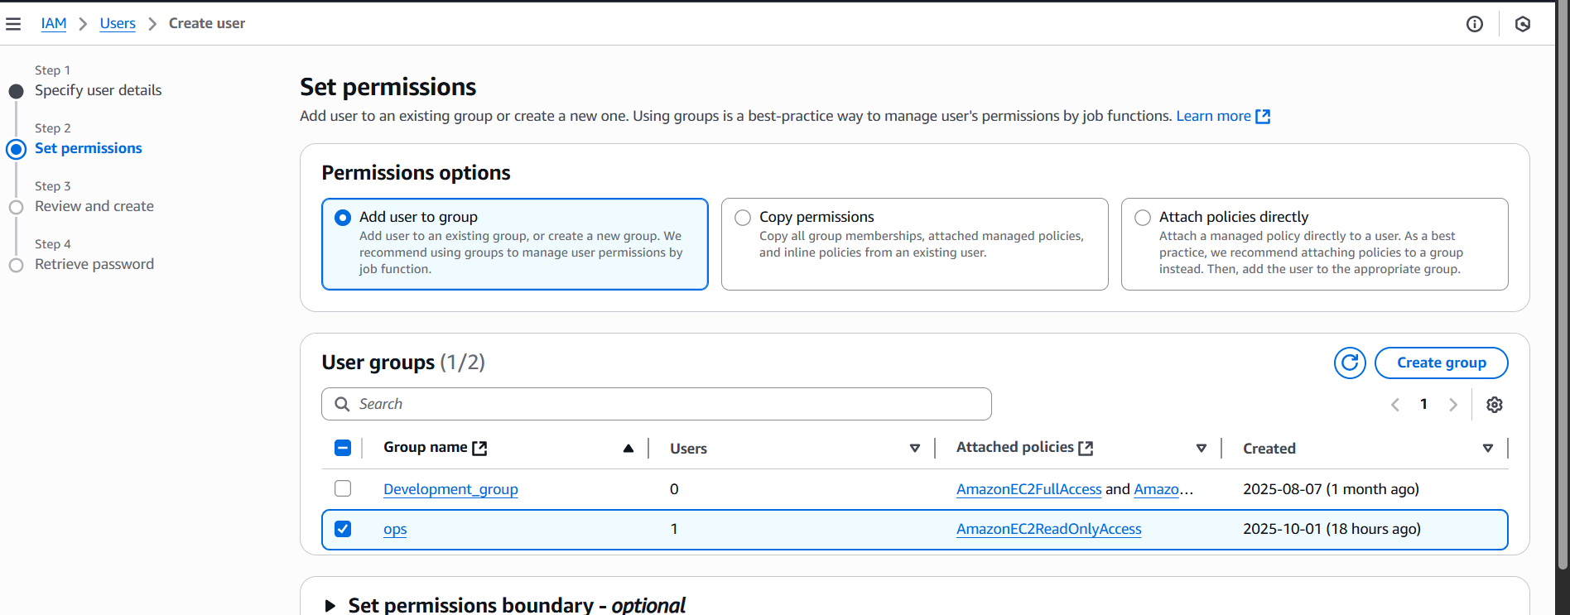

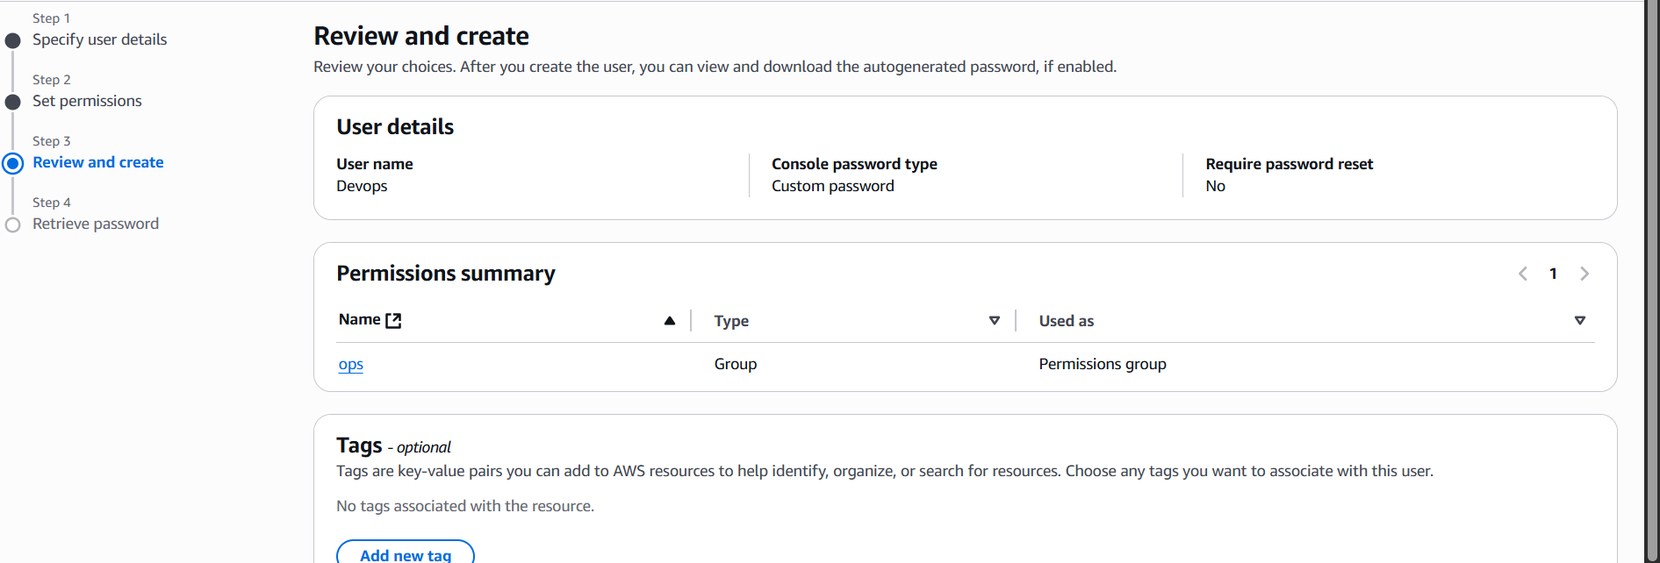

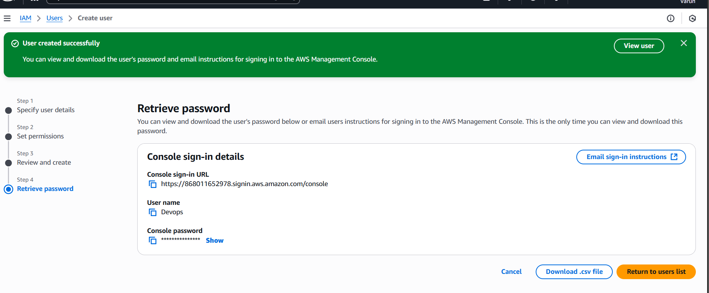

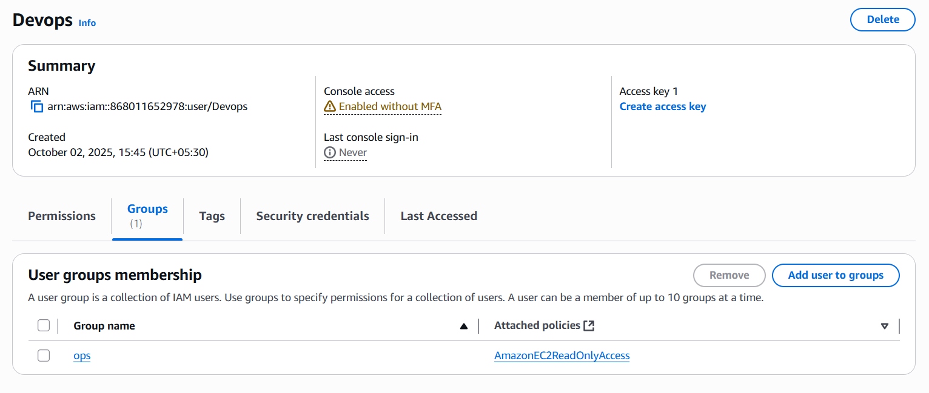

* Login to root user of aws console.
* Go to IAM services and click Users and create a user as above images.
* Attach the user to the existing group ops.
* It will create an IAM user with existing access of the group we created.

1. Write a bash script to create an IAM user with VPC full access.

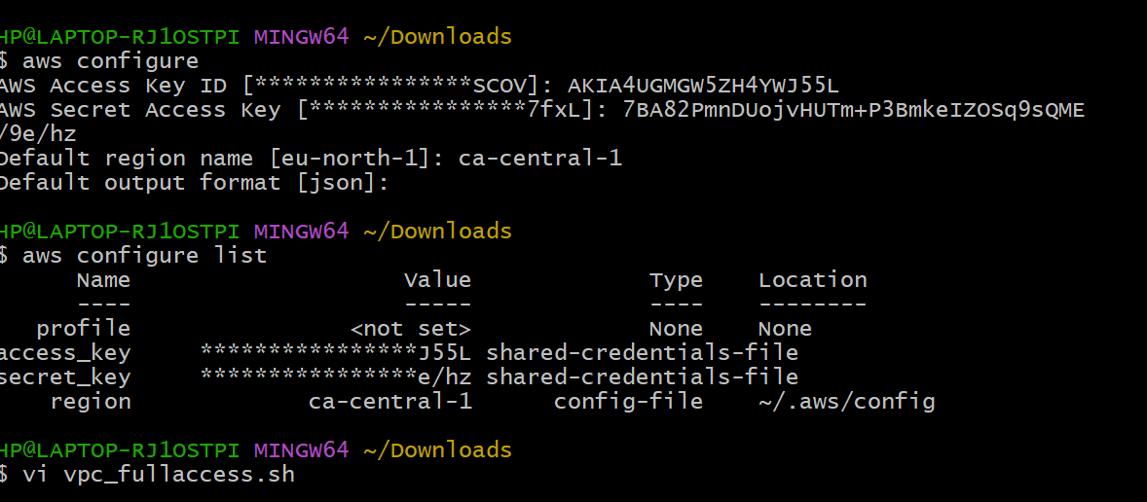

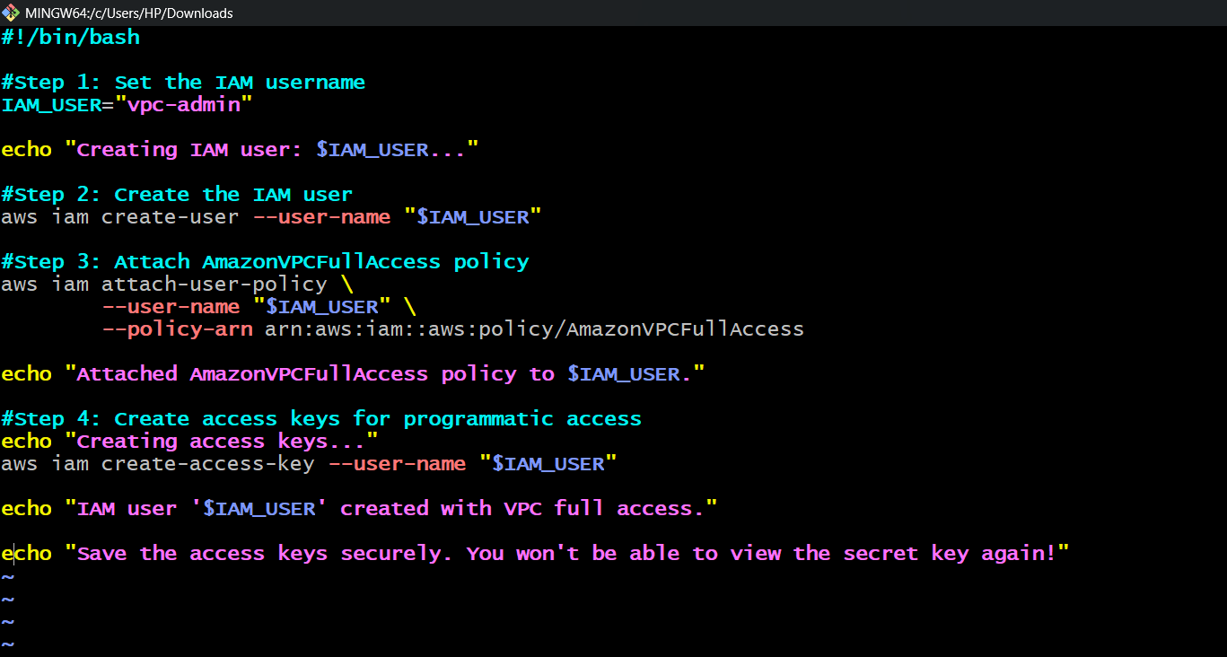

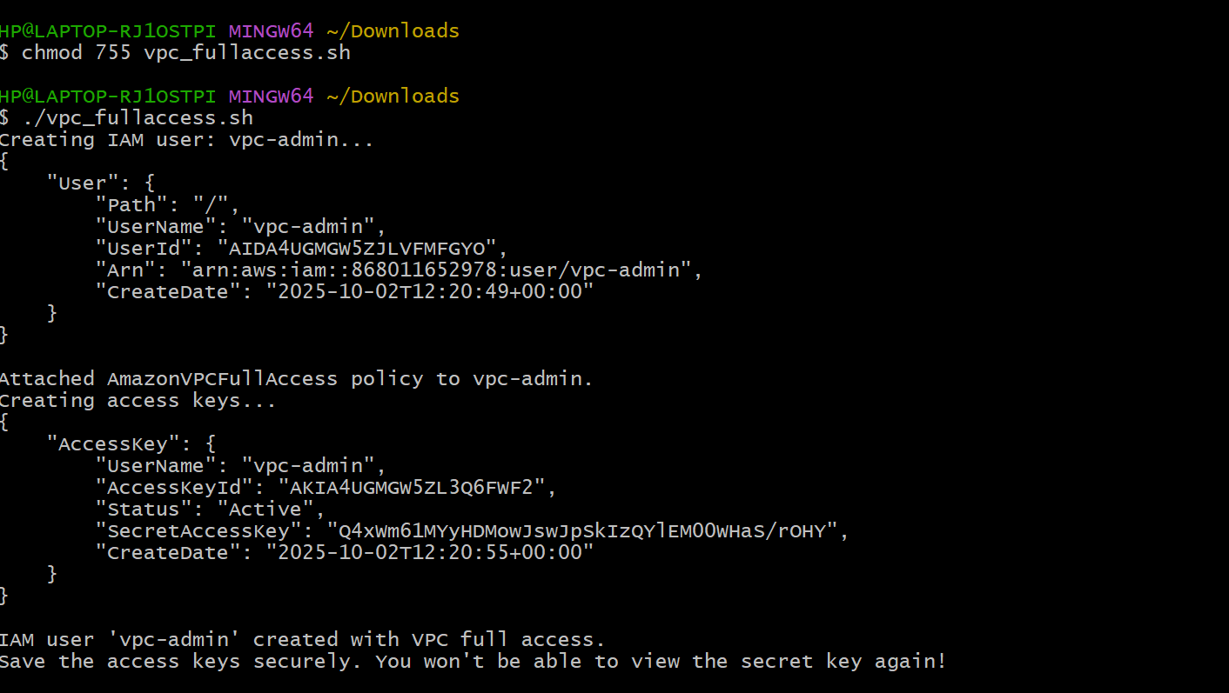

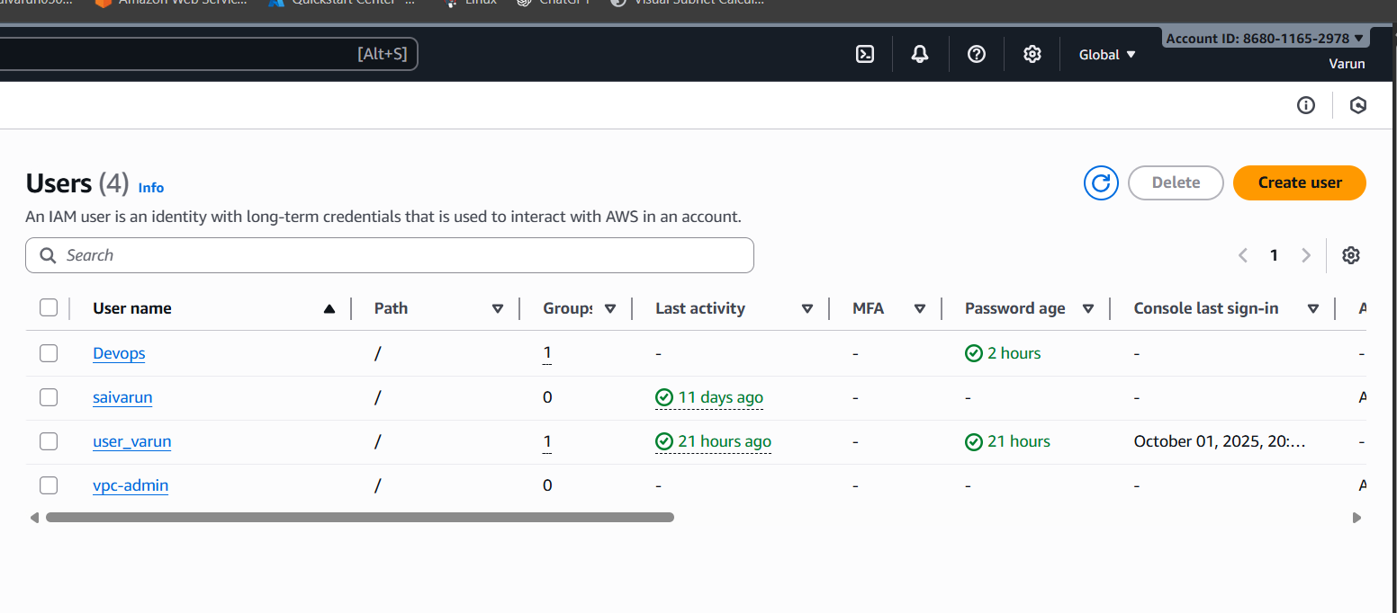

1. Create an IAM policy to allow EC2 access for a specific user in specific regions only.

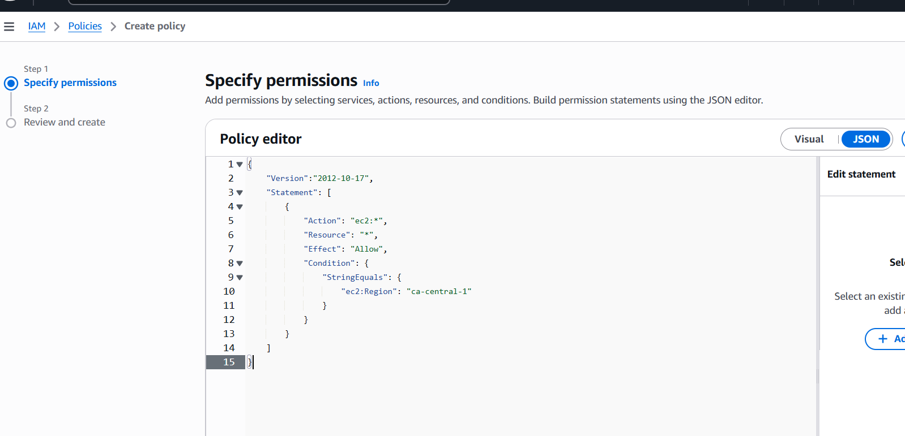

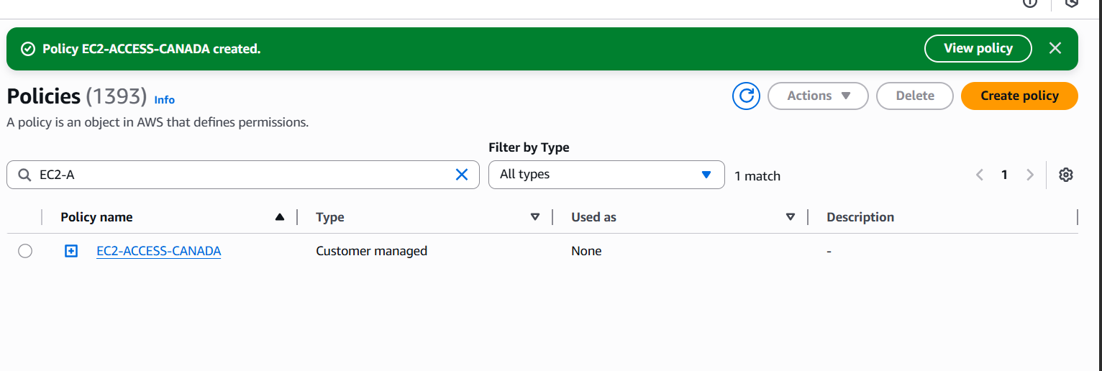

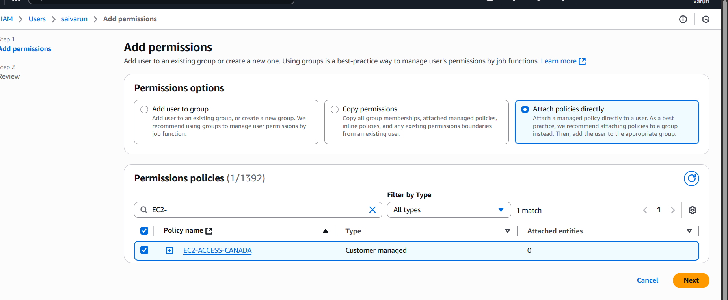

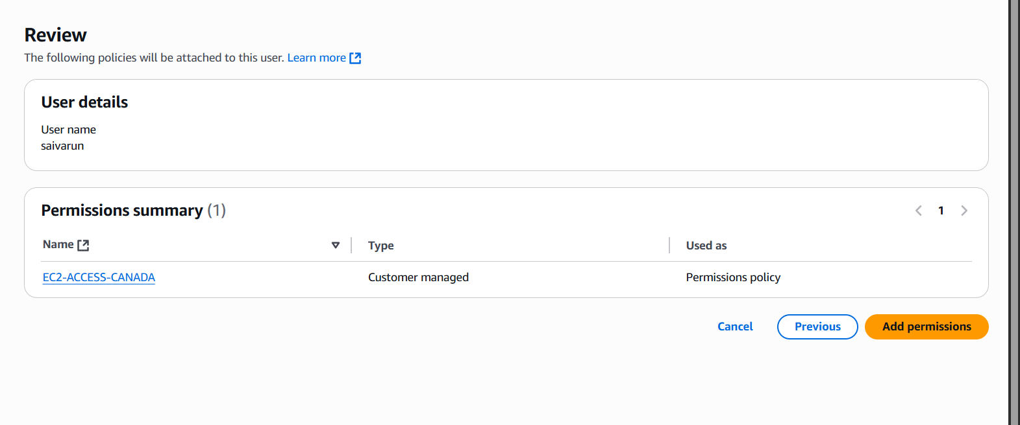

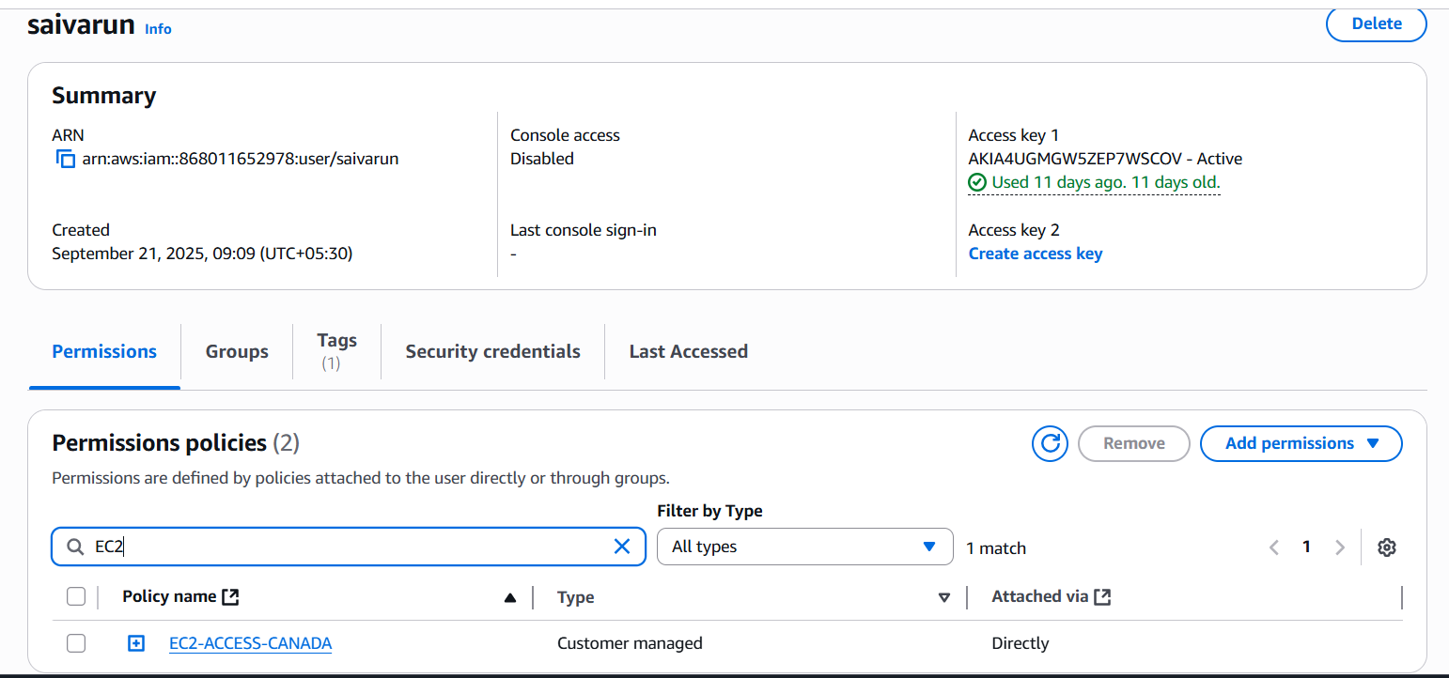

Go to AWS Console  
•Click Policies in the left sidebar  
•Click Create Policy  
•Choose the JSON tab  
•Paste the policy JSON above and name it as EC2-ACCESS-CANADA, Then click create policy.

Select the IAM User  
•Select the user you want to restrict  
•Click the Permissions tab  
•Click Add Permissions  
•Choose Attach policies directly and attach the policy we created.